Fitzgerald, Brett (from CALM News 1997)
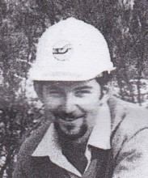
His grandfather joined the Forests Department as an apprentice at Ludlow in 1924, later becoming chief timber inspector for Kirup. Brett’s father also worked for 44 years with the Forests Department, as administration officer in Kirup. Brett joined CALM in 1995, after completing a degree in Environmental Biology at Curtin University. He continued his studies on a part time basis, completing Honours. In 1997 he worked at Kirup in Blackwood District, primarily in Nature Conservation and also fire control. In 2001 he was based in Denham, Shark Bay District, in Midwest Region, as a project officer (Project Eden).

